Percentile report for Placement data

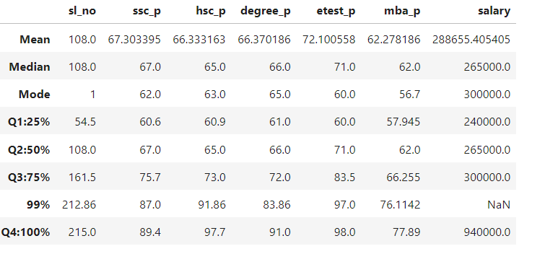

SSC Score Analysis

* First quadrant(25%) of students scored 60.6 in SSC and next 25% that means second quadrant (50%) of students scored 67.0marks ,the increase percentage of 25% to 50% is 7%
* Second quadrant score(50%) is 67 and Third quadrant mark(75%) is 75.7 and the increase percentage between 50% to 75% is 8.7%
* Third quadrant(75%) of students scored 75.7 in SSC and the highest percentage 99% is 87 ,the difference between 75% to 995 is 2.4 %
* The Fourth quadrant (100% )of students scored 89.4 marks and the difference between last two highest percentages are 2.4%

HSC Score Analysis

* First quadrant(25%) of students scored 60.9 in HSC and next 25% that means second quadrant (50%) of students scored 65.0marks ,the increase percentage of 25% to 50% is 5%
* Second quadrant score(50%) is 65 and Third quadrant mark(75%) is 73 and the increase percentage between 50% to 75% is 8%
* Third quadrant(75%) of students scored 73 in HSC and the highest percentage 99% is 91.8,the difference between 75% to 995 is 18.8%
* The Fourth quadrant (100% )of students scored 97.7 marks and the difference between last two highest percentages are 5.9%

Degree Score Analysis

* First quadrant(25%) of students scored 61 in Degree and next 25% that means second quadrant (50%) of students scored 66 marks ,the increase percentage of 25% to 50% is 7%
* Second quadrant score(50%) is 66 and Third quadrant mark(75%) is 72 and the increase percentage between 50% to 75% is 6%
* Third quadrant(75%) of students scored 72 in Degree and the highest percentage 99% is 83.8 ,the difference between 75% to 99% is 11.8%
* The Fourth quadrant (100% )of students scored 91 marks and the difference between last two highest percentages are 7.2%

Entrance test Score Analysis

* First quadrant(25%) of students scored 60 in Entrance and next 25% that means second quadrant (50%) of students scored 71 marks ,the increase percentage of 25% to 50% is 11%
* Second quadrant score(50%) is 71 and Third quadrant mark(75%) is 83.5 and the increase percentage between 50% to 75% is 12.5%
* Third quadrant(75%) of students scored 83.5 in Entrance and the highest percentage 99% is 97 ,the difference between 75% to 99% is 13.5%
* The Fourth quadrant (100% )of students scored 98 marks and the difference between last two highest percentages are 1%

MBA Score Analysis

* First quadrant(25%) of students scored 57.9 in MBA and next 25% that means second quadrant (50%) of students scored 62 marks ,the increase percentage of 25% to 50% is 4.1%
* Second quadrant score(50%) is 62 and Third quadrant mark(75%) is 66.2 and the increase percentage between 50% to 75% is 4.2%
* Third quadrant(75%) of students scored 66.2 in MBA and the highest percentage 99% is 76.1,the difference between 75% to 99% is 9.9%
* The Fourth quadrant (100% )of students scored 77.8 marks and the difference between last two highest percentages are 1.7%